

SYMBIOSIS INTERNATIONAL (DEEMED UNIVERSITY)
(Established under section 3 of the UGC Act 1956)
Re-accredited by NAAC with “A” Grade

Name of the Student: Sneha Sah PRN: 25070122189
Semester: 3 Year: AY 25-29
ASSIGNMENT No: 14
TITLE: Write a Java program to demonstrate exception handling using try and catch blocks, nested and multiple try-catch blocks.
Problem Statement: Write a Java program to demonstrate exception handling using try and catch blocks, nested and multiple try-catch blocks.
Theory: Exception handling prevents abnormal termination of programs due to runtime errors. The try block contains code that may generate exceptions, while catch blocks handle specific exceptions. Nested and multiple try-catch structures allow complex error management. Exception handling improves software reliability and user experience by gracefully managing unexpected situations. Exercise 1. Create an ATM program handling invalid withdrawal amount using try-catch 2. Create an Online Shopping program that handles an invalid product quantity entered by the user using a try-catch block. Display an appropriate error message if the quantity is less than or equal to zero.
Syntax:
try {
// code that may cause exception
}
catch (ExceptionType e) {
// exception handling code
}

Exercise
1. Create an ATM program handling invalid withdrawal amount using try-catch.
Source code:
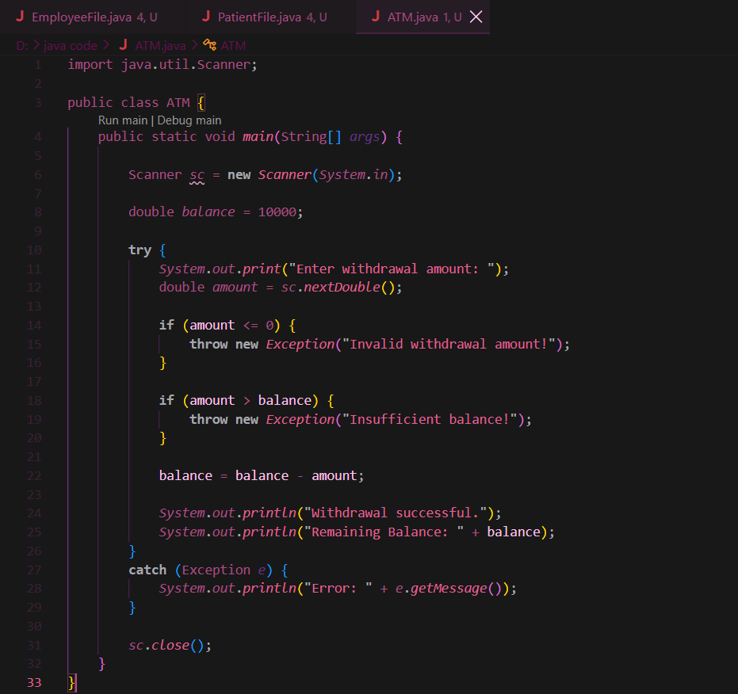
Output:
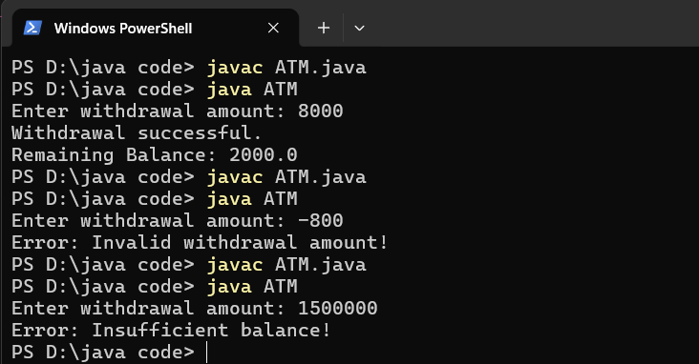
2. Create an Online Shopping program that handles an invalid product quantity entered by the user using a try-catch block. Display an appropriate error message if the quantity is less than or equal to zero.
Source code:
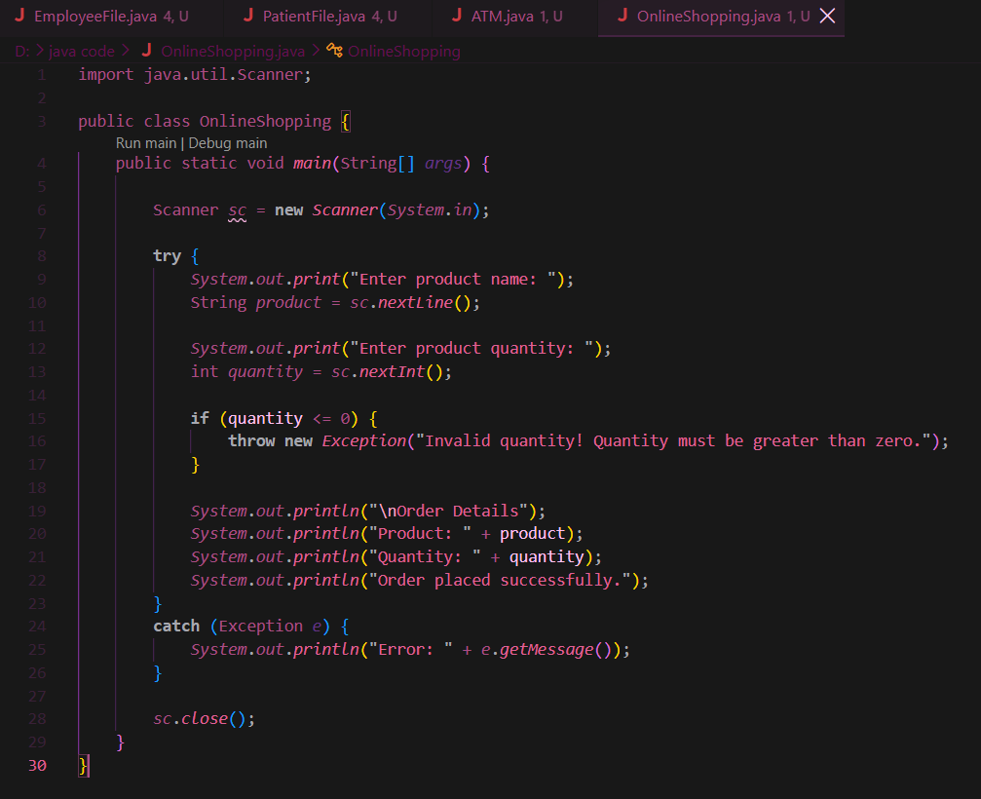
Output:
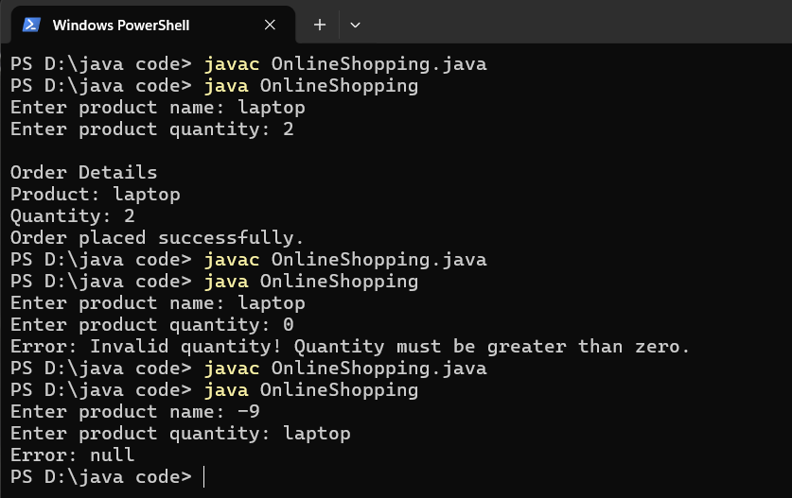

Conclusion
Thus, the experiment was successfully completed using exception handling in Java. The try-catch blocks were used to handle invalid withdrawal amounts in an ATM program and invalid product quantities in an online shopping program. This helps prevent abnormal program termination and allows the program to display meaningful error messages to the user.

